Pastoral Care 24% of the budget Our Pastoral Care includes hospital and home visits, communion for shut-ins, sending a note to someone in need, holding each other in prayer, lending an ear to a friend, and so much more.  Education 16% of the budget From Camp Agape and Sunday Children’s Worship for children to small groups, in-depth classes, and book studies for adults, educational opportunities for all abound.  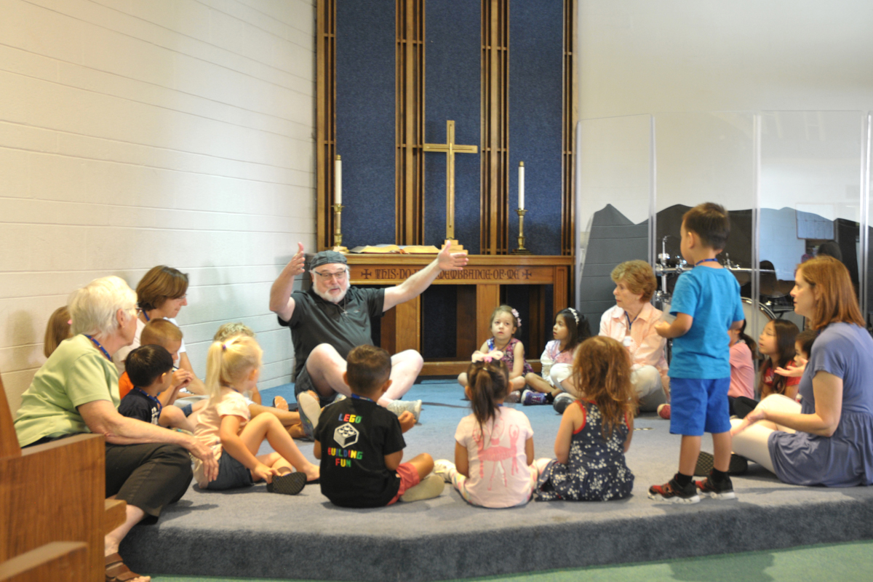 | Who We Are  Our Vision  As a community hub, connect with the needs of people, joyfully sharing Jesus and serving where God calls.  Our Mission Love God, Love People…Serve  Contact Us  First Presbyterian Church Concord  1965 Colfax St.  Concord, CA 94520  Phone: 925-676-7177  Email: fpcc@fpcconcord.org  Web: www.fpcconcord.org | First Presbyterian Church Concord  - Narrative Budget 2020
FPCC 2020 Operating Budget by Category $552,548  Our Ministries  FPCC uses the resources that God has graciously given us to carry out the mission and ministry to which we have been called. God expects us to be good stewards, plan wisely, and generously share our resources with everyone we meet. This narrative budget seeks to reflect not only the costs behind what it takes to run our mission and ministry, but also the story behind the success of our programs and the difference that they make in our church and community. | Worship & Music  34% of the budget From Sunday morning worship services to special events such as the Spring concert, crafting a reverent and meaningful worship experience is a continual joy. Communion is served the first Sunday of each month, the choir and praise band perform regularly throughout the year, and baptisms are performed as requested.  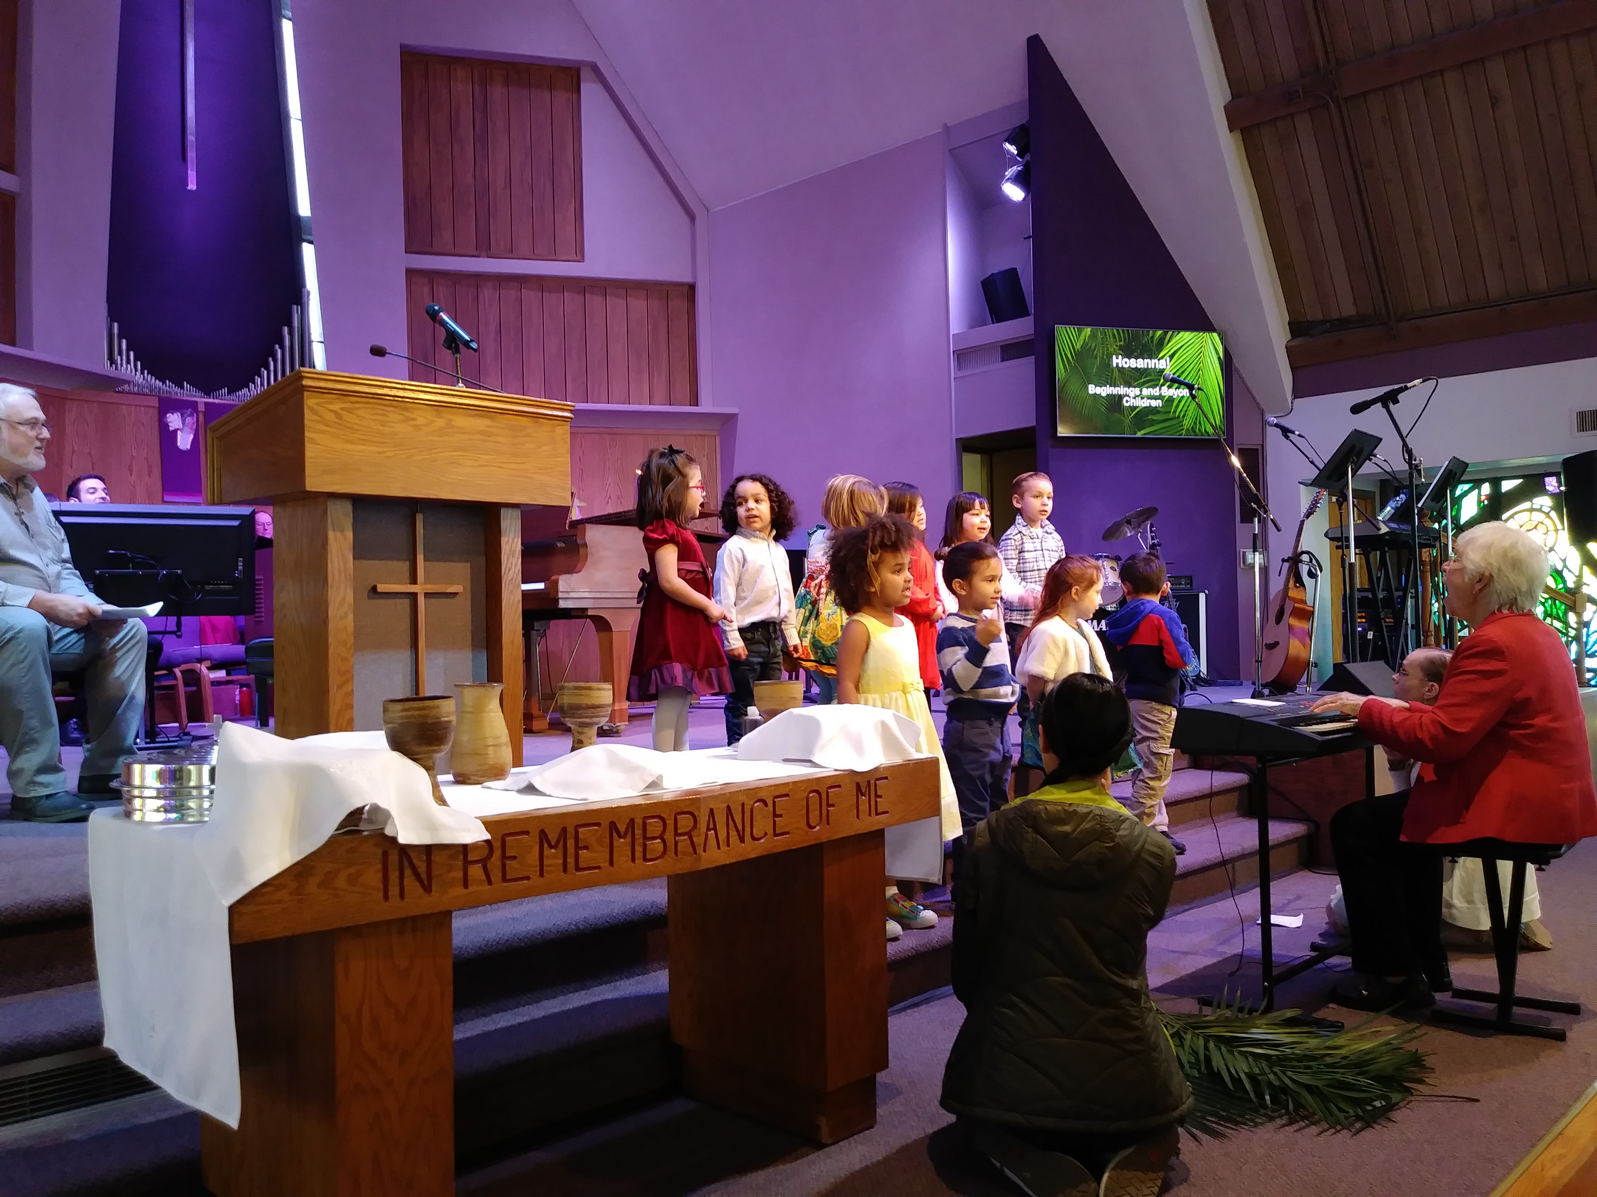  Plus, each worship service is live-streamed on Facebook so no one has to miss out, no matter how far away they may be. Tune in at facebook.com/1stPresConcord/. | Missions & Outreach  26% of the budget FPCC is honored to support the work of Nathanael and Darla Gregoriev (pictured) with Wycliffe Associates in Cameroon, Christy Reiners with In His Steps in Palestine, and Caroline Kurtz in Ethiopia, all of whom came to visit us this summer. FPCC also supports dozens of other mission partners all over the world and right here in Concord including Contra Costa Interfaith Housing and Winter Nights Shelter. And FPCC’s Outreach supports a variety of programs serving our immediate community including Alpha classes, welcoming visitors and new members, and much more!

